OS Lab Experiment IX

Varun Khadayate

NMIMS

# AIM

WAP to implement contiguous memory allocation using:

1. First Fit Algo
2. Best Fit Algo

Consider the relevant data for the number and size of blocks as well as for the number and size of processes.

# CODE

## First Fit Algo

#include<iostream>

#include<string.h>

using namespace std;

int main()

{

int bsize[10], psize[10], bno, pno, flags[10], allocation[10], i, j;

for(i = 0; i < 10; i++)

{

flags[i] = 0;

allocation[i] = -1;

}

cout<<"Enter no. of blocks: ";

cin>>bno;

cout<<"\nEnter size of each block: ";

for(i = 0; i < bno; i++)

{

cin>>bsize[i];

}

cout<<"\nEnter no. of processes: ";

cin>>pno;

cout<<"\nEnter size of each process: ";

for(i = 0; i < pno; i++)

{

cin>>psize[i];

}

for(i = 0; i < pno; i++)

for(j = 0; j < bno; j++)

if(flags[j] == 0 && bsize[j] >= psize[i])

{

allocation[j] = i;

flags[j] = 1;

break;

}

cout<<"\nBlock no.\tsize\t\tprocess no.\t\tsize";

for(i = 0; i < bno; i++)

{

cout<<"\n"<< i+1<<"\t\t"<<bsize[i]<<"\t\t";

if(flags[i] == 1)

cout<<allocation[i]+1<<"\t\t\t"<<psize[allocation[i]];

else

cout<<"Not allocated";

}

return 0;

}

## Best Fit Algo

#include<iostream>

#include<string.h>

using namespace std;

int main()

{

int fragment[20],b[20],p[20],i,j,nb,np,temp,lowest=9999;

static int barray[20],parray[20];

cout<<"\nEnter the number of blocks:";

cin>>nb;

cout<<"Enter the number of processes:";

cin>>np;

cout<<"\nEnter the size of the blocks:-\n";

for(i=1;i<=nb;i++)

{

cout<<"Block no."<<i<<":";

cin>>b[i];

}

cout<<"\nEnter the size of the processes :-\n";

for(i=1;i<=np;i++)

{

cout<<"Process no. "<<i<<":";

cin>>p[i];

}

for(i=1;i<=np;i++)

{

for(j=1;j<=nb;j++)

{

if(barray[j]!=1)

{

temp=b[j]-p[i];

if(temp>=0)

if(lowest>temp)

{

parray[i]=j;

lowest=temp;

}

}

}

fragment[i]=lowest;

barray[parray[i]]=1;

lowest=10000;

}

cout<<"\nProcess_no\tProcess_size\tBlock_no\tBlock_size\tFragment";

for(i=1;i<=np && parray[i]!=0;i++)

{

cout<<"\n"<<i<<"\t\t"<<p[i]<<"\t\t"<<parray[i]<<"\t\t"<<b[parray[i]]<<"\t\t"<<fragment[i];

}

return 0;

}

# OUPUT

## First Fit Algo

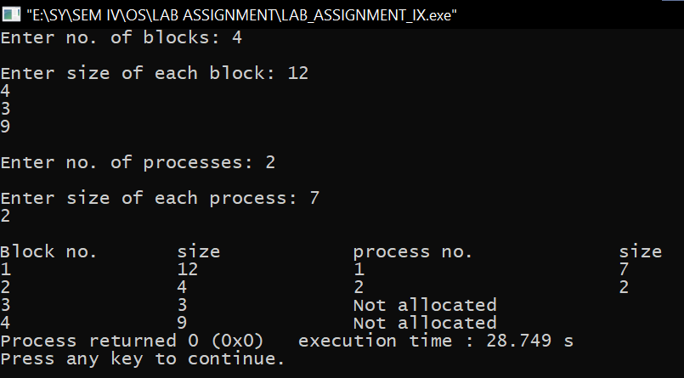

## Best Fit Algo

